SQL Queries with Problem Statements
Key Performance Indicators (KPIs):
- Total Revenue: The sum of the total price of all pizza orders.
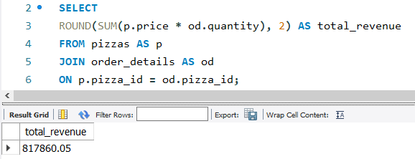
- Total Orders: The total quantity of orders that have been placed
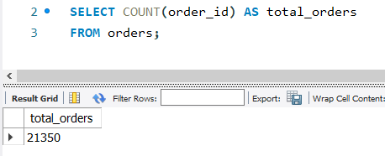
- Average Order Value: The average amount spent per order.
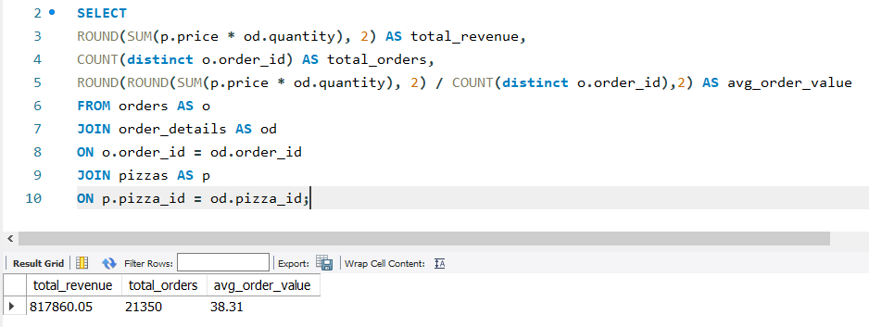
- Total Pizza Sold: The sum of the quantities of all pizzas sold.
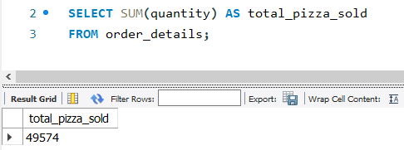
- Average Daily Pizza Orders: The average quantity of pizzas ordered on a daily basis.
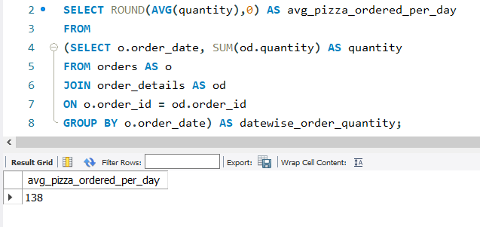
Analytical Insights:
- Find the pizza with the highest price.
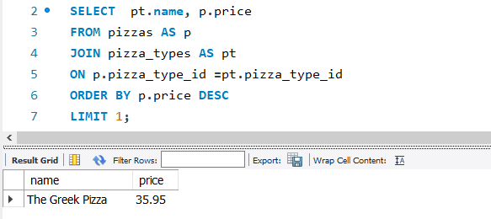
- Determine the distribution of pizza orders based on their respective sizes.
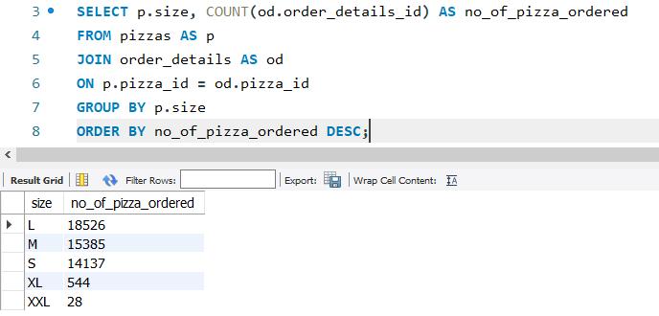

- Provide a list of the five most ordered pizza types, including the quantity of each.
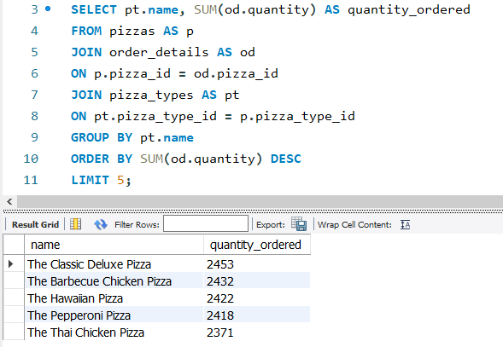
- Determine the overall quantity of each category of pizzas ordered.
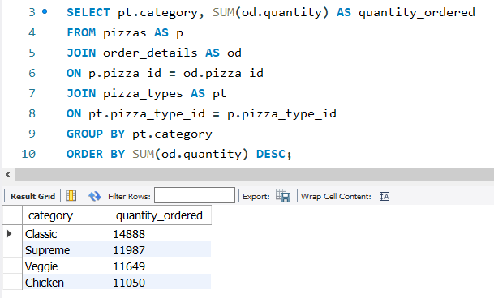
- Identify the distribution of orders based on the hour of the day.
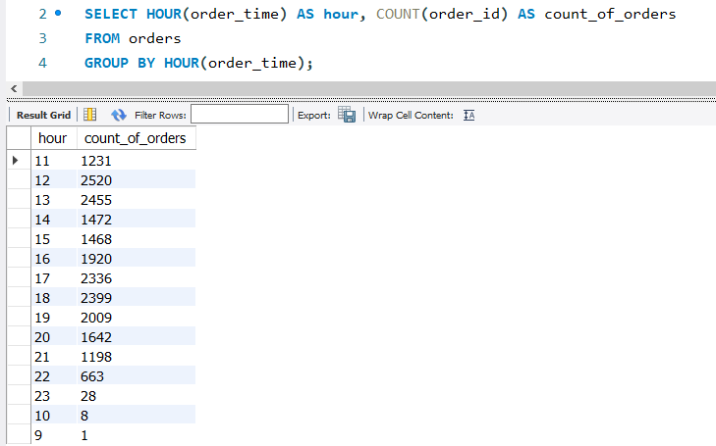
- Determine the quantity of all available pizzas within each category
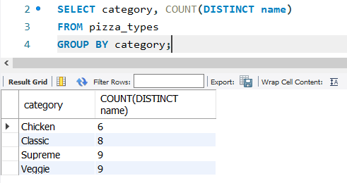
- Identify the three pizza types with the highest revenue from orders.
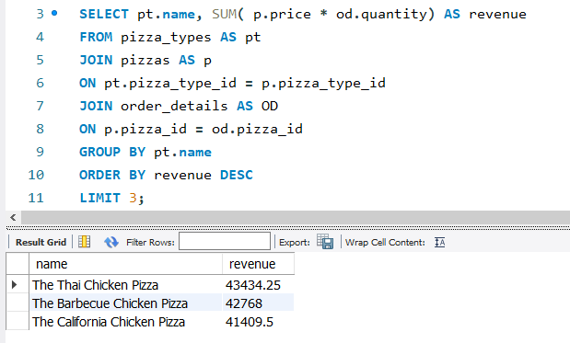
- Determine the proportion of total revenue contributed by each pizza category.
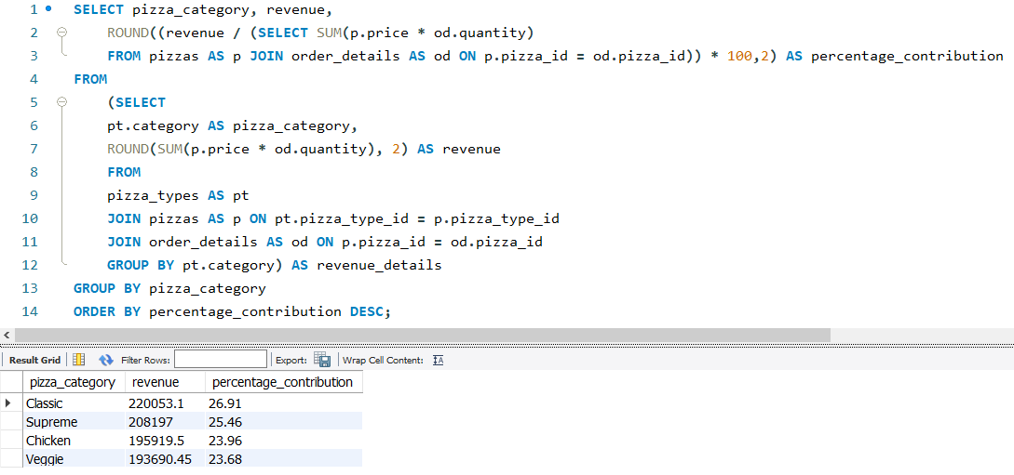
- Examine the total revenue accumulated across months.
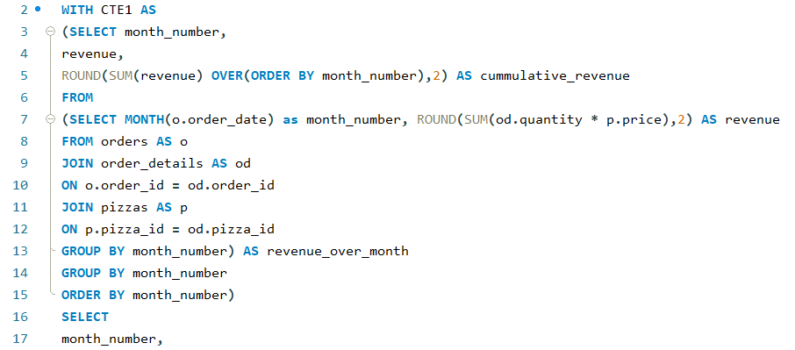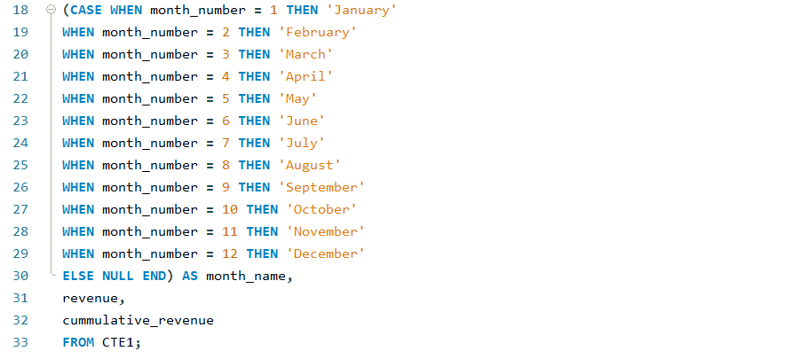
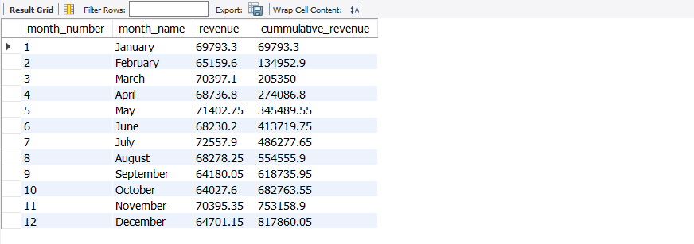

- Identify the top three pizza types with the highest revenue within each pizza category.
